High Point Hybrid Tutorials Student Application
Student Application for Enrollment 2023-2024
1002 Center Point Rd, Hendersonville, Tn 37075
Tuition is $1,200 per semester (second child is $1,080 third child is $1,000)
Student Name | Current  Grade | 2023/2024  Grade | Date of Birth

Parent(s) Name(s): _________________________________________
Street Address: _____________________ City: _____________ Zip Code: _____
*E-Mail: ___________________________________
Home/Cell Phone: ____________________________________
*All communication including billing is sent via email.
Mother’s Cell Phone:_________________________________
Father’s Cell Phone: _________________________________
Emergency Contact (person other than parent) and phone/cell number
______________________________________________________________________________________________________________________________________________
Who is allowed to pick up your child(ren)? ________________________________________________________________________________________________________________________________________________________________________________________________________________________
Does your child(ren) have any special needs we need to know about? If yes, please explain:___________________________________________________________________________________________________________________________________
Does your child(ren) presently take on-going prescription medication? If yes, please list: __________________________________________________
Does your child(ren) have any physical, emotional, or other problems that may affect his/her behavior? If so, which child(ren) ____________ If yes, please explain ________________________________________________________________
Does your child(ren) have any allergies? If so, which child(ren):_______
Please list: ________________________________________________________
Has your child(ren) always been home schooled? If not, please list previous education experiences:_________________________________________________
Please initial:
Throughout the school year, High Point will post pictures of our students on the website and High Point’s Facebook. I agree that my child’s picture may be posted. ____OR
Please do NOT post ANY pictures of my child. ___________
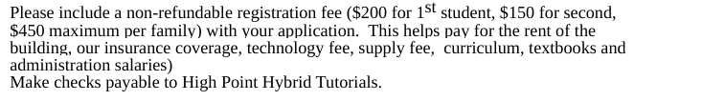

Signature: ________________________________ Date: ________________

***If enrolled by April 1st, then registration fee will be waived.***

